Proiect SGBD – gestiunea unui dealer auto

# Descrierea problemei economice

Baza de date prezentata abordeaza problema gestionarii eficiente a unui service auto, concentrandu-se pe managementul pieselor de schimb, programarilor, clientilor si facturilor. Structura bazei de date include tabele pentru vehicule, piese de schimb, servicii, clienti, programari si facturi, interconectate prin chei primare si straine. Aceasta permite urmarirea stocurilor de piese, detaliilor de service pentru fiecare vehicul, gestionarea programarilor clientilor si generarea facturilor corespunzatoare. Prin centralizarea acestor informatii, baza de date faciliteaza accesul rapid la date esentiale, reduce erorile administrative si imbunatateste experienta clientului printr-o organizare eficienta si precisa a activitatilor din service-ul auto.

# Schema relationala

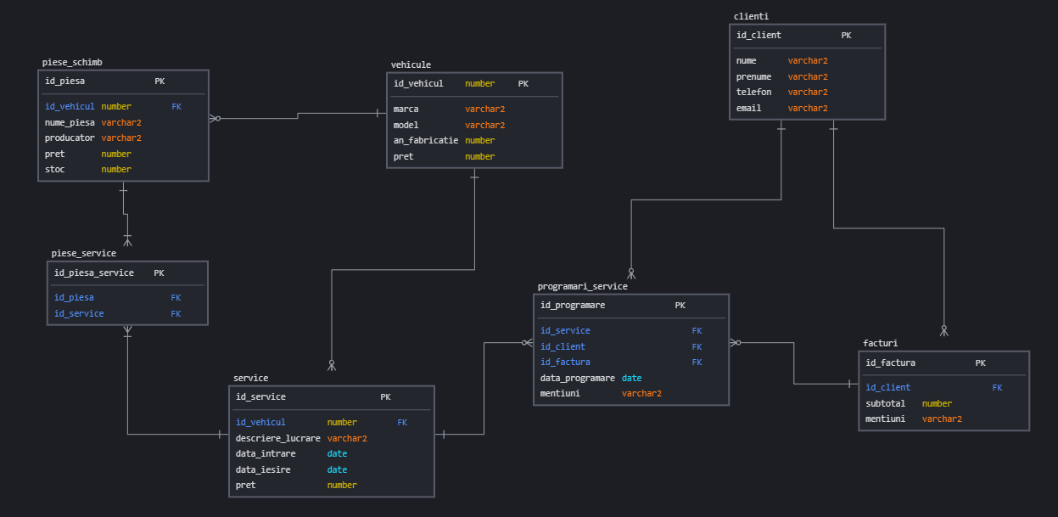

# Script de creare a tabelelor

CREATE TABLE dealer_clienti (

id_client NUMBER PRIMARY KEY,

nume VARCHAR2(50),

prenume VARCHAR2(50),

telefon VARCHAR2(15),

email VARCHAR2(50)

);

CREATE TABLE dealer_vehicule (

id_vehicul NUMBER PRIMARY KEY,

marca VARCHAR2(50),

model VARCHAR2(50),

an_fabricatie NUMBER,

pret NUMBER

);

CREATE TABLE dealer_service (

id_service NUMBER PRIMARY KEY,

id_vehicul NUMBER,

descriere_lucrare VARCHAR2(200),

data_intrare DATE,

data_iesire DATE,

pret NUMBER,

CONSTRAINT fk_service_vehicul FOREIGN KEY (id_vehicul) REFERENCES dealer_vehicule(id_vehicul)

);

CREATE TABLE dealer_piese_schimb (

id_piesa NUMBER PRIMARY KEY,

id_vehicul NUMBER,

nume_piesa VARCHAR2(50),

producator VARCHAR2(50),

pret NUMBER,

stoc NUMBER,

CONSTRAINT fk_piese_vehicul FOREIGN KEY (id_vehicul) REFERENCES dealer_vehicule(id_vehicul)

);

CREATE TABLE dealer_piese_service (

id_piesa_service NUMBER PRIMARY KEY,

id_piesa NUMBER,

id_service NUMBER,

CONSTRAINT fk_piese_service_piesa FOREIGN KEY (id_piesa) REFERENCES dealer_piese_schimb(id_piesa),

CONSTRAINT fk_piese_service_service FOREIGN KEY (id_service) REFERENCES dealer_service(id_service)

);

CREATE TABLE dealer_facturi (

id_factura NUMBER PRIMARY KEY,

id_client NUMBER,

subtotal NUMBER,

mentiuni VARCHAR2(200),

CONSTRAINT fk_facturi_clienti FOREIGN KEY (id_client) REFERENCES dealer_clienti(id_client)

);

CREATE TABLE dealer_programari_service (

id_programmare NUMBER PRIMARY KEY,

id_service NUMBER,

id_client NUMBER,

id_factura NUMBER,

data_programare DATE,

mentiuni VARCHAR2(200),

CONSTRAINT fk_programari_service FOREIGN KEY (id_service) REFERENCES dealer_service(id_service),

CONSTRAINT fk_programari_client FOREIGN KEY (id_client) REFERENCES dealer_clienti(id_client),

CONSTRAINT fk_programari_factura FOREIGN KEY (id_factura) REFERENCES dealer_facturi(id_factura)

);

# Comenzi de populare a tabelelor

INSERT INTO dealer_clienti (id_client, nume, prenume, telefon, email) VALUES (1, 'Popescu', 'Ion', '0720123456', 'ion.popescu@example.com');

INSERT INTO dealer_clienti (id_client, nume, prenume, telefon, email) VALUES (2, 'Ionescu', 'Maria', '0720987654', 'maria.ionescu@example.com');

INSERT INTO dealer_clienti (id_client, nume, prenume, telefon, email) VALUES (3, 'Georgescu', 'Andrei', '0720345678', 'andrei.georgescu@example.com');

INSERT INTO dealer_clienti (id_client, nume, prenume, telefon, email) VALUES (4, 'Dumitrescu', 'Elena', '0720765432', 'elena.dumitrescu@example.com');

INSERT INTO dealer_clienti (id_client, nume, prenume, telefon, email) VALUES (5, 'Marinescu', 'Alex', '0720987123', 'alex.marinescu@example.com');

INSERT INTO dealer_vehicule (id_vehicul, marca, model, an_fabricatie, pret) VALUES (1, 'Dacia', 'Duster', 2020, 15000);

INSERT INTO dealer_vehicule (id_vehicul, marca, model, an_fabricatie, pret) VALUES (2, 'Renault', 'Clio', 2019, 12000);

INSERT INTO dealer_vehicule (id_vehicul, marca, model, an_fabricatie, pret) VALUES (3, 'Ford', 'Focus', 2018, 13000);

INSERT INTO dealer_vehicule (id_vehicul, marca, model, an_fabricatie, pret) VALUES (4, 'Volkswagen', 'Golf', 2021, 20000);

INSERT INTO dealer_vehicule (id_vehicul, marca, model, an_fabricatie, pret) VALUES (5, 'Toyota', 'Corolla', 2017, 14000);

INSERT INTO dealer_service (id_service, id_vehicul, descriere_lucrare, data_intrare, data_iesire, pret) VALUES (1, 1, 'Schimb ulei', TO_DATE('2024-05-01', 'YYYY-MM-DD'), TO_DATE('2024-05-02', 'YYYY-MM-DD'), 100);

INSERT INTO dealer_service (id_service, id_vehicul, descriere_lucrare, data_intrare, data_iesire, pret) VALUES (2, 2, 'Revizie tehnica', TO_DATE('2024-05-03', 'YYYY-MM-DD'), TO_DATE('2024-05-04', 'YYYY-MM-DD'), 200);

INSERT INTO dealer_service (id_service, id_vehicul, descriere_lucrare, data_intrare, data_iesire, pret) VALUES (3, 3, 'Inlocuire placute frana', TO_DATE('2024-05-05', 'YYYY-MM-DD'), TO_DATE('2024-05-06', 'YYYY-MM-DD'), 150);

INSERT INTO dealer_service (id_service, id_vehicul, descriere_lucrare, data_intrare, data_iesire, pret) VALUES (4, 4, 'Schimb anvelope', TO_DATE('2024-05-07', 'YYYY-MM-DD'), TO_DATE('2024-05-08', 'YYYY-MM-DD'), 300);

INSERT INTO dealer_service (id_service, id_vehicul, descriere_lucrare, data_intrare, data_iesire, pret) VALUES (5, 5, 'Verificare generala', TO_DATE('2024-05-09', 'YYYY-MM-DD'), TO_DATE('2024-05-10', 'YYYY-MM-DD'), 250);

INSERT INTO dealer_piese_schimb (id_piesa, id_vehicul, nume_piesa, producator, pret, stoc) VALUES (1, 1, 'Filtru ulei', 'Bosch', 50, 10);

INSERT INTO dealer_piese_schimb (id_piesa, id_vehicul, nume_piesa, producator, pret, stoc) VALUES (2, 2, 'Bujie', 'NGK', 30, 20);

INSERT INTO dealer_piese_schimb (id_piesa, id_vehicul, nume_piesa, producator, pret, stoc) VALUES (3, 3, 'Placute frana', 'Brembo', 80, 15);

INSERT INTO dealer_piese_schimb (id_piesa, id_vehicul, nume_piesa, producator, pret, stoc) VALUES (4, 4, 'Anvelopa', 'Continental', 100, 25);

INSERT INTO dealer_piese_schimb (id_piesa, id_vehicul, nume_piesa, producator, pret, stoc) VALUES (5, 5, 'Baterie auto', 'Varta', 150, 5);

INSERT INTO dealer_piese_service (id_piesa_service, id_piesa, id_service) VALUES (1, 1, 1);

INSERT INTO dealer_piese_service (id_piesa_service, id_piesa, id_service) VALUES (2, 2, 2);

INSERT INTO dealer_piese_service (id_piesa_service, id_piesa, id_service) VALUES (3, 3, 3);

INSERT INTO dealer_piese_service (id_piesa_service, id_piesa, id_service) VALUES (4, 4, 4);

INSERT INTO dealer_piese_service (id_piesa_service, id_piesa, id_service) VALUES (5, 5, 5);

INSERT INTO dealer_facturi (id_factura, id_client, subtotal, mentiuni) VALUES (1, 1, 150, 'Plata cash');

INSERT INTO dealer_facturi (id_factura, id_client, subtotal, mentiuni) VALUES (2, 2, 230, 'Plata card');

INSERT INTO dealer_facturi (id_factura, id_client, subtotal, mentiuni) VALUES (3, 3, 180, 'Plata cash');

INSERT INTO dealer_facturi (id_factura, id_client, subtotal, mentiuni) VALUES (4, 4, 320, 'Plata card');

INSERT INTO dealer_facturi (id_factura, id_client, subtotal, mentiuni) VALUES (5, 5, 275, 'Plata cash');

INSERT INTO dealer_programari_service (id_programmare, id_service, id_client, id_factura, data_programare, mentiuni) VALUES (1, 1, 1, 1, TO_DATE('2024-04-30', 'YYYY-MM-DD'), 'Programare online');

INSERT INTO dealer_programari_service (id_programmare, id_service, id_client, id_factura, data_programare, mentiuni) VALUES (2, 2, 2, 2, TO_DATE('2024-05-02', 'YYYY-MM-DD'), 'Programare telefonica');

INSERT INTO dealer_programari_service (id_programmare, id_service, id_client, id_factura, data_programare, mentiuni) VALUES (3, 3, 3, 3, TO_DATE('2024-05-04', 'YYYY-MM-DD'), 'Programare online');

INSERT INTO dealer_programari_service (id_programmare, id_service, id_client, id_factura, data_programare, mentiuni) VALUES (4, 4, 4, 4, TO_DATE('2024-05-06', 'YYYY-MM-DD'), 'Programare telefonica');

INSERT INTO dealer_programari_service (id_programmare, id_service, id_client, id_factura, data_programare, mentiuni) VALUES (5, 5, 5, 5, TO_DATE('2024-05-08', 'YYYY-MM-DD'), 'Programare online');

# Structuri de control, cursori impliciti/expliciti

1. Verificam daca exista client in baza de date.

BEGIN

DECLARE

v_num_clienti NUMBER;

BEGIN

SELECT COUNT(*) INTO v_num_clienti FROM dealer_clienti;

IF v_num_clienti > 0 THEN

DBMS_OUTPUT.PUT_LINE('Exista ' || v_num_clienti || ' clienti in baza de date.');

ELSE

DBMS_OUTPUT.PUT_LINE('Nu exista clienti in baza de date.');

END IF;

END;

END;

/

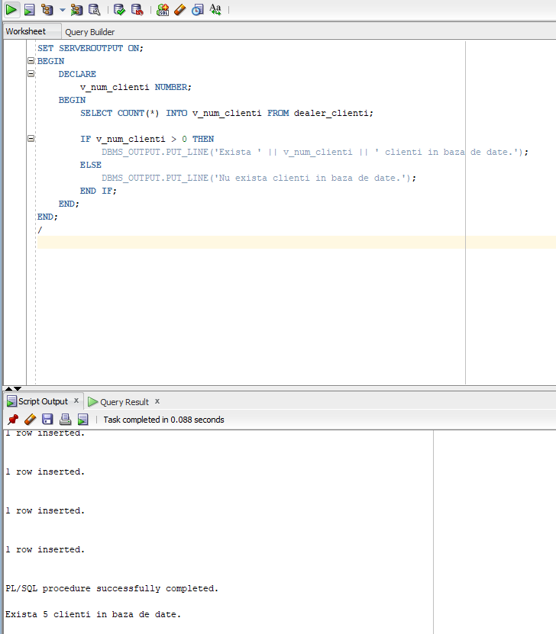

2. Afisarea clientilor care au cel putin o factura in BD printr-un cursor explicit

DECLARE

CURSOR client_cursor IS

SELECT c.nume, c.prenume

FROM dealer_clienti c

JOIN dealer_facturi f ON c.id_client = f.id_client;

v_nume dealer_clienti.nume%TYPE;

v_prenume dealer_clienti.prenume%TYPE;

BEGIN

OPEN client_cursor;

LOOP

FETCH client_cursor INTO v_nume, v_prenume;

EXIT WHEN client_cursor%NOTFOUND;

DBMS_OUTPUT.PUT_LINE('Client: ' || v_nume || ' ' || v_prenume);

END LOOP;

CLOSE client_cursor;

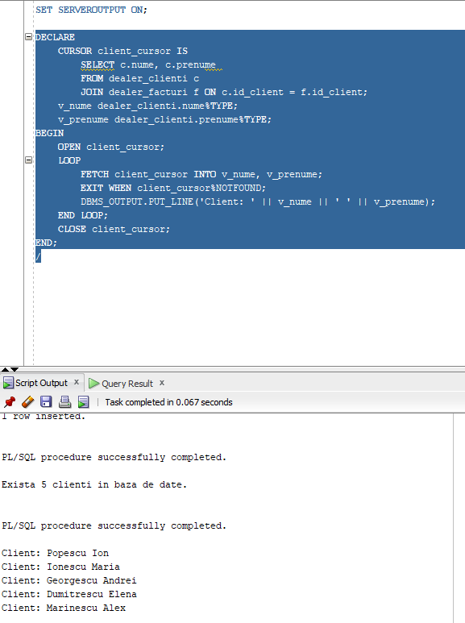END;

/

3. Actualizarea pretului vehiculelor mai vechi de un anumit an. Verificarea nr. de modificari prin cursor implicit

BEGIN

DECLARE

v_an_nou NUMBER := 2018;

v_pret_nou NUMBER := 10000;

BEGIN

UPDATE dealer_vehicule

SET pret = v_pret_nou

WHERE an_fabricatie < v_an_nou;

IF SQL%ROWCOUNT > 0 THEN

DBMS_OUTPUT.PUT_LINE(SQL%ROWCOUNT || ' vehicule au fost actualizate.');

ELSE

DBMS_OUTPUT.PUT_LINE('Nu s-au efectuat modificari.');

END IF;

EXCEPTION

WHEN OTHERS THEN

DBMS_OUTPUT.PUT_LINE('Eroare: ' || SQLERRM);

END;

END;

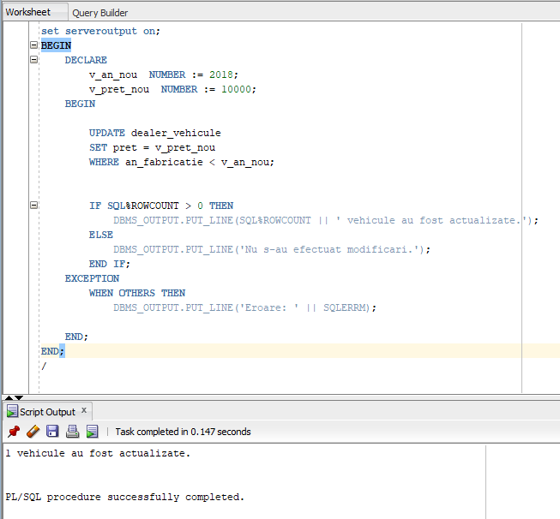/

4. Stergerea clientilor fara facturi folosind cursori explicit/implicit si exceptii aferente.

BEGIN

DECLARE

CURSOR clienti_cursor IS

SELECT c.id_client

FROM dealer_clienti c

WHERE NOT EXISTS (SELECT 1 FROM dealer_facturi f WHERE f.id_client = c.id_client);

v_id_client dealer_clienti.id_client%TYPE;

v_exista_clienti BOOLEAN := FALSE;

BEGIN

OPEN clienti_cursor;

LOOP

FETCH clienti_cursor INTO v_id_client;

EXIT WHEN clienti_cursor%NOTFOUND;

v_exista_clienti := TRUE;

DELETE FROM dealer_clienti

WHERE id_client = v_id_client;

IF SQL%ROWCOUNT > 0 THEN

DBMS_OUTPUT.PUT_LINE('Clientul cu ID-ul ' || v_id_client || ' a fost sters.');

ELSE

DBMS_OUTPUT.PUT_LINE('Clientul cu ID-ul ' || v_id_client || ' nu exista.');

END IF;

END LOOP;

CLOSE clienti_cursor;

IF NOT v_exista_clienti THEN

DBMS_OUTPUT.PUT_LINE('Nu au fost gasiti clienti fara facturi.');

END IF;

COMMIT;

EXCEPTION

WHEN OTHERS THEN

DBMS_OUTPUT.PUT_LINE('Eroare: ' || SQLERRM);

ROLLBACK;

END;

END;

/

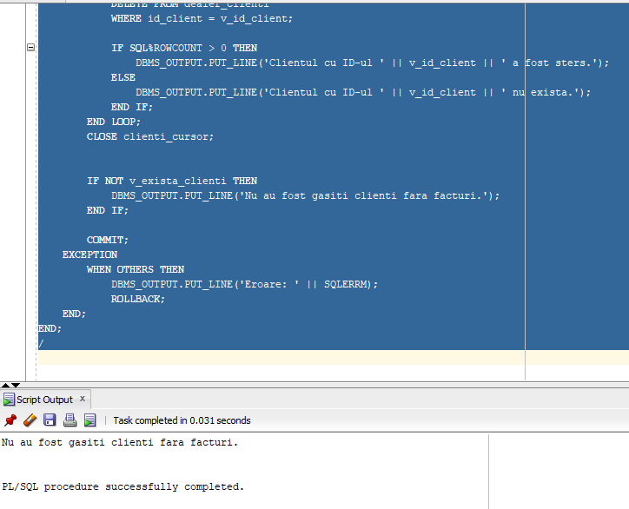

5. Listarea clientilor si vehiculelor asociate, inclusiv pretul total al pieselor schimbate.

SET SERVEROUTPUT ON;

DECLARE

CURSOR clienti_vehicule_cursor IS

SELECT c.id_client, c.nume, c.prenume, v.id_vehicul, v.marca, v.model

FROM dealer_clienti c

JOIN dealer_programari_service ps ON c.id_client = ps.id_client

JOIN dealer_service s ON ps.id_service = s.id_service

JOIN dealer_vehicule v ON s.id_vehicul = v.id_vehicul;

clienti_vehicule_rec clienti_vehicule_cursor%ROWTYPE;

CURSOR piese_cursor (v_id_vehicul NUMBER) IS

SELECT SUM(p.pret) AS total_pret

FROM dealer_piese_schimb p

WHERE p.id_vehicul = v_id_vehicul;

piese_rec piese_cursor%ROWTYPE;

BEGIN

DBMS_OUTPUT.PUT_LINE('Lista clienților și vehiculelor asociate:');

OPEN clienti_vehicule_cursor;

LOOP

FETCH clienti_vehicule_cursor INTO clienti_vehicule_rec;

EXIT WHEN clienti_vehicule_cursor%NOTFOUND;

DBMS_OUTPUT.PUT_LINE('Client: ' || clienti_vehicule_rec.nume || ' ' || clienti_vehicule_rec.prenume ||

', Vehicul: ' || clienti_vehicule_rec.marca || ' ' || clienti_vehicule_rec.model);

OPEN piese_cursor(clienti_vehicule_rec.id_vehicul);

FETCH piese_cursor INTO piese_rec;

IF piese_cursor%FOUND THEN

DBMS_OUTPUT.PUT_LINE(' Pret total piese schimbate: ' || NVL(piese_rec.total_pret, 0));

ELSE

DBMS_OUTPUT.PUT_LINE(' Nu există piese schimbate pentru acest vehicul.');

END IF;

CLOSE piese_cursor;

END LOOP;

CLOSE clienti_vehicule_cursor;

END;

/

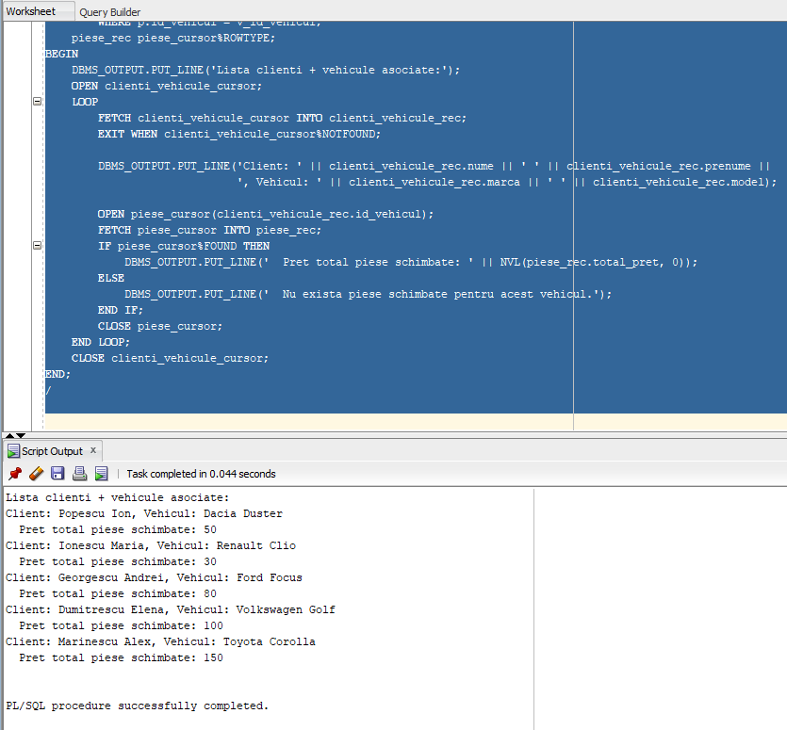

# Exceptii implicite/explicite. Tratarea exceptiilor.

1. Verificarea validitatii datei de intrare a unui vehicul in service printr-o exceptie definita de utilizator.

SET SERVEROUTPUT ON;

DECLARE

e_date_exception EXCEPTION;

v_data_iesire DATE;

BEGIN

SELECT data_iesire INTO v_data_iesire

FROM dealer_service

WHERE id_service = 1;

IF v_data_iesire > SYSDATE THEN

RAISE e_date_exception;

END IF;

DBMS_OUTPUT.PUT_LINE('Data de iesire este valida: ' || TO_CHAR(v_data_iesire, 'YYYY-MM-DD'));

EXCEPTION

WHEN e_date_exception THEN

DBMS_OUTPUT.PUT_LINE('Data de iesire invalida: ' || TO_CHAR(v_data_iesire, 'YYYY-MM-DD'));

END;

/

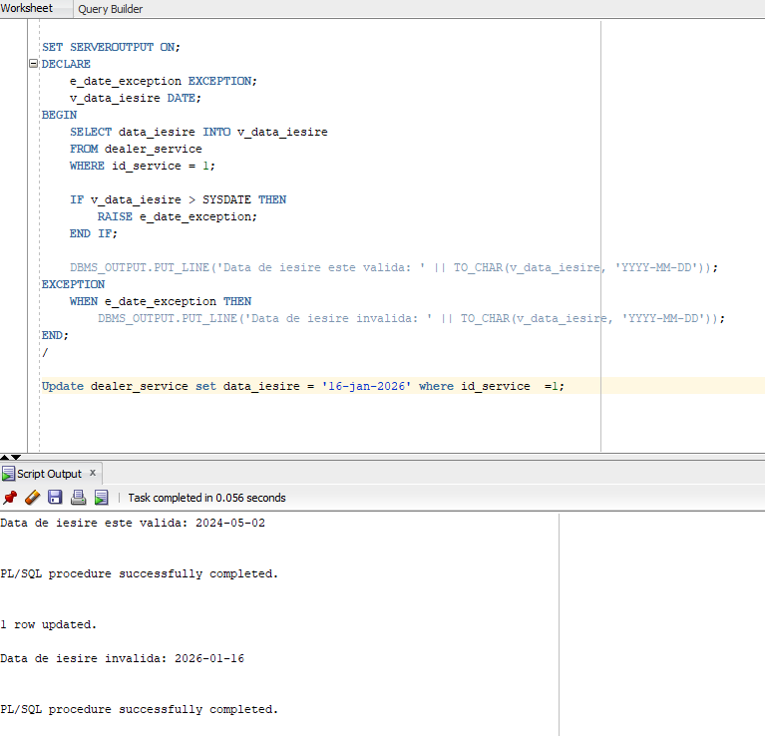

1. Verificarea totalului pieselor schimbate pentru un vehicul. Tratarea exceptiilor.

SET SERVEROUTPUT ON;

DECLARE

v_id_vehicul NUMBER := 6;

v_total_pret NUMBER;

e_fara_piese EXCEPTION;

BEGIN

SELECT SUM(p.pret) INTO v_total_pret

FROM dealer_piese_schimb p

WHERE p.id_vehicul = v_id_vehicul;

IF v_total_pret IS NULL THEN

RAISE e_fara_piese;

END IF;

DBMS_OUTPUT.PUT_LINE('Pretul total al pieselor schimbate pentru vehiculul cu ID ' || v_id_vehicul || ' este: ' || v_total_pret);

EXCEPTION

WHEN e_fara_piese THEN

DBMS_OUTPUT.PUT_LINE('Nu exista piese schimbate pentru vehiculul cu ID ' || v_id_vehicul || '.');

WHEN OTHERS THEN

DBMS_OUTPUT.PUT_LINE('Eroare: ' || SQLERRM);

END;

/

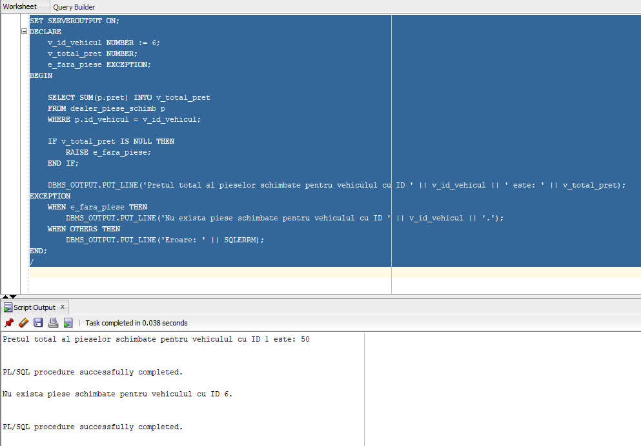

1. Crearea unui raport al programarilor si tratarea exceptiilor aferente:

SET SERVEROUTPUT ON;

DECLARE

CURSOR clienti_cursor IS

SELECT c.id_client, c.nume, COUNT(ps.id_programmare) AS numar_programari, SUM(f.subtotal) AS suma_facturi

FROM dealer_clienti c

LEFT JOIN dealer_programari_service ps ON c.id_client = ps.id_client

LEFT JOIN dealer_facturi f ON ps.id_factura = f.id_factura

GROUP BY c.id_client, c.nume;

clienti_rec clienti_cursor%ROWTYPE;

BEGIN

DBMS_OUTPUT.PUT_LINE('Raport programari:');

OPEN clienti_cursor;

LOOP

FETCH clienti_cursor INTO clienti_rec;

EXIT WHEN clienti_cursor%NOTFOUND;

DBMS_OUTPUT.PUT_LINE('Clientul ' || clienti_rec.nume || ' are ' || clienti_rec.numar_programari || ' programari si suma totala a facturilor este: ' || clienti_rec.suma_facturi);

END LOOP;

CLOSE clienti_cursor;

EXCEPTION

WHEN NO_DATA_FOUND THEN

DBMS_OUTPUT.PUT_LINE('Nu exista date disponibile pentru generarea raportului.');

WHEN TOO_MANY_ROWS THEN

DBMS_OUTPUT.PUT_LINE('Eroare: Prea multe randuri gasite');

WHEN OTHERS THEN

DBMS_OUTPUT.PUT_LINE('Eroare: ' || SQLERRM);

ROLLBACK;

END;

/

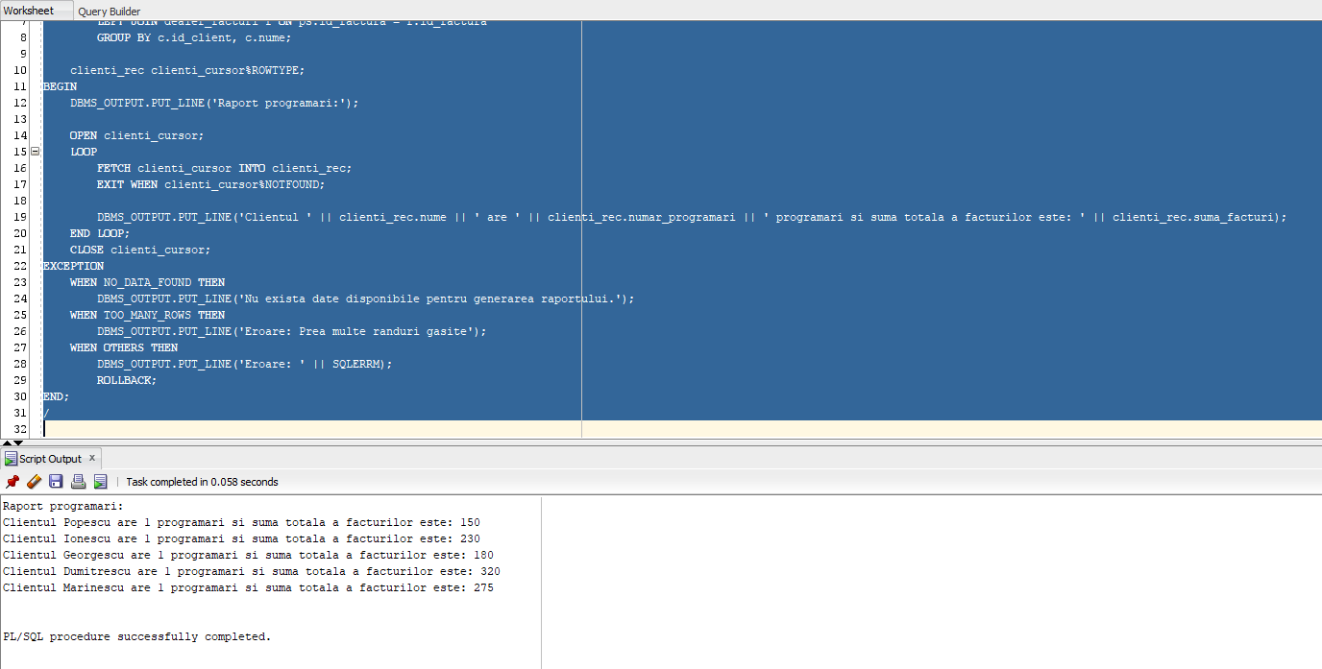

1. Verificarea stocului de piese si compararea acestuia cu o valoare luata de la tastatura printr-o variabila de substitutie. Declararea si tratarea exceptiilor.

DECLARE

v_id_vehicul dealer_vehicule.id_vehicul%TYPE := 1;

v_id_piesa dealer_piese_schimb.id_piesa%TYPE;

v_stoc_piesa dealer_piese_schimb.stoc%TYPE;

v_limita_piese NUMBER := &a;

CURSOR c_piese IS

SELECT id_piesa, stoc

FROM dealer_piese_schimb

WHERE id_vehicul = v_id_vehicul;

e_stoc_insuficient EXCEPTION;

BEGIN

OPEN c_piese;

LOOP

FETCH c_piese INTO v_id_piesa, v_stoc_piesa;

EXIT WHEN c_piese%NOTFOUND;

IF v_stoc_piesa < v_limita_piese THEN

RAISE e_stoc_insuficient;

ELSE

DBMS_OUTPUT.PUT_LINE('Stoc suficient pentru piesa cu ID-ul ' || v_id_piesa);

END IF;

END LOOP;

CLOSE c_piese;

EXCEPTION

WHEN NO_DATA_FOUND THEN

DBMS_OUTPUT.PUT_LINE('Nu exista piese de schimb!' || SQLERRM);

WHEN e_stoc_insuficient THEN

DBMS_OUTPUT.PUT_LINE('Stoc insuficient pentru piesa cu ID-ul ' || v_id_piesa);

WHEN OTHERS THEN

DBMS_OUTPUT.PUT_LINE('Eroare: ' || SQLERRM);

END;

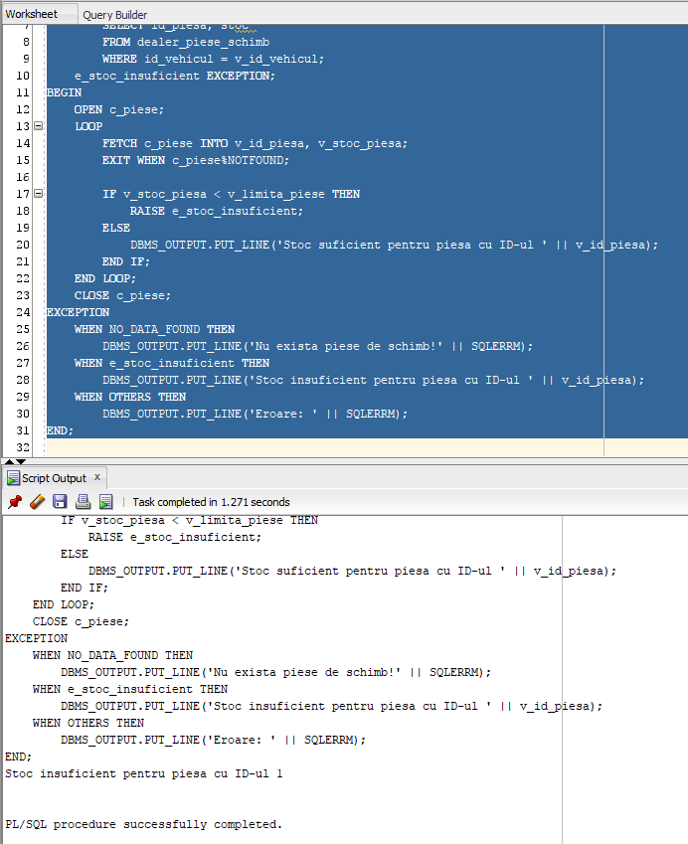

# Proceduri si Functii. Pachete de subprograme.

Am creat pachetul “MY_PROC_PACK” care contine 4 proceduri.

Antet:

CREATE OR REPLACE PACKAGE MY_PROC_PACK IS

PROCEDURE ADAUGARE_STOC_PIESA( p_id IN NUMBER, p_cantitate IN NUMBER);

PROCEDURE VALOARE_INVENTAR_MARCA(p_marca IN VARCHAR2,p_valoare OUT NUMBER);

PROCEDURE INSERARE_CLIENT(p_id IN NUMBER,p_nume IN VARCHAR2, p_prenume IN VARCHAR2, p_telefon IN VARCHAR2, p_email IN VARCHAR2);

PROCEDURE STERGERE_VEHICUL(p_id IN NUMBER);

END;

Body:

SET SERVEROUTPUT ON;

CREATE OR REPLACE PACKAGE BODY MY_PROC_PACK IS

PROCEDURE ADAUGARE_STOC_PIESA( p_id IN NUMBER, p_cantitate IN NUMBER) IS

v_stoc_nou NUMBER;

BEGIN

SELECT stoc INTO v_stoc_nou

FROM dealer_piese_schimb

WHERE id_piesa = p_id;

v_stoc_nou:= v_stoc_nou + p_cantitate;

UPDATE dealer_piese_schimb

SET stoc = v_stoc_nou

WHERE id_piesa = p_id;

IF SQL%ROWCOUNT = 0 THEN

RAISE_APPLICATION_ERROR(-20001, 'Piesa nu a fost gasita.');

END IF;

DBMS_OUTPUT.PUT_LINE('Stcocul piesei cu ID ' || p_id || ' este: ' || v_stoc_nou);

EXCEPTION

WHEN OTHERS THEN

RAISE_APPLICATION_ERROR(-20002, 'Eroare la actualizarea stocului.');

END;

PROCEDURE VALOARE_INVENTAR_MARCA(p_marca IN VARCHAR2,p_valoare OUT NUMBER) IS

BEGIN

SELECT SUM(pret) INTO p_valoare

FROM dealer_vehicule

WHERE UPPER(marca) = UPPER(p_marca);

EXCEPTION

WHEN NO_DATA_FOUND THEN

RAISE_APPLICATION_ERROR(-20003, 'Marca specificata nu exista pe stoc.');

END;

PROCEDURE INSERARE_CLIENT(p_id IN NUMBER,p_nume IN VARCHAR2, p_prenume IN VARCHAR2, p_telefon IN VARCHAR2, p_email IN VARCHAR2) IS

BEGIN

INSERT INTO dealer_clienti VALUES

(p_id,p_nume,p_prenume,p_telefon,p_email);

IF SQL%ROWCOUNT = 0 THEN

RAISE_APPLICATION_ERROR(-20004, 'Clientul nu a putut fi inserat!');

END IF;

DBMS_OUTPUT.PUT_LINE('Client inserat cu succes: ' || p_id || ' , ' || p_nume || ' , ' || p_prenume || ' , ' || p_telefon || ' , ' || p_email);

EXCEPTION

WHEN OTHERS THEN

RAISE_APPLICATION_ERROR(-20005, 'Eroare la inserarea clientului!');

END;

PROCEDURE STERGERE_VEHICUL(p_id IN NUMBER) IS

v_cnt NUMBER;

BEGIN

SELECT COUNT(*)

INTO v_cnt

FROM dealer_piese_schimb

WHERE id_vehicul = p_id;

IF v_cnt > 0 THEN

RAISE_APPLICATION_ERROR(-20006, 'Vehiculul nu poate fi sters deoarece exista in dealer_piese_schimb.');

END IF;

SELECT COUNT(*)

INTO v_cnt

FROM dealer_service

WHERE id_vehicul = p_id;

IF v_cnt > 0 THEN

RAISE_APPLICATION_ERROR(-20007, 'Vehiculul nu poate fi sters deoarece exista in dealer_service.');

END IF;

DELETE FROM dealer_vehicule

WHERE id_vehicul = p_id;

IF SQL%ROWCOUNT = 0 THEN

RAISE_APPLICATION_ERROR(-20008, 'Vehiculul nu a fost gasit.');

END IF;

DBMS_OUTPUT.PUT_LINE('Vehicul sters cu succes!');

EXCEPTION

WHEN OTHERS THEN

RAISE_APPLICATION_ERROR(-20009, 'Eroare la stergerea vehiculului.');

END;

END;

Apeluri:

DECLARE

v_val NUMBER:=0;

BEGIN

my_proc_pack.adaugare_stoc_piesa(1, 10);

my_proc_pack.valoare_inventar_marca('Dacia',v_val);

DBMS_OUTPUT.PUT_LINE('Valoare vehiculelor cu marca selectata: ' || v_val);

my_proc_pack.inserare_client(6,'Ionut','Voicu','0799999999','voicudaniel22@stud.ase.ro');

my_proc_pack.stergere_vehicul(6);

END;

Screenshot-uri:

Adaugare_stoc_piesa:

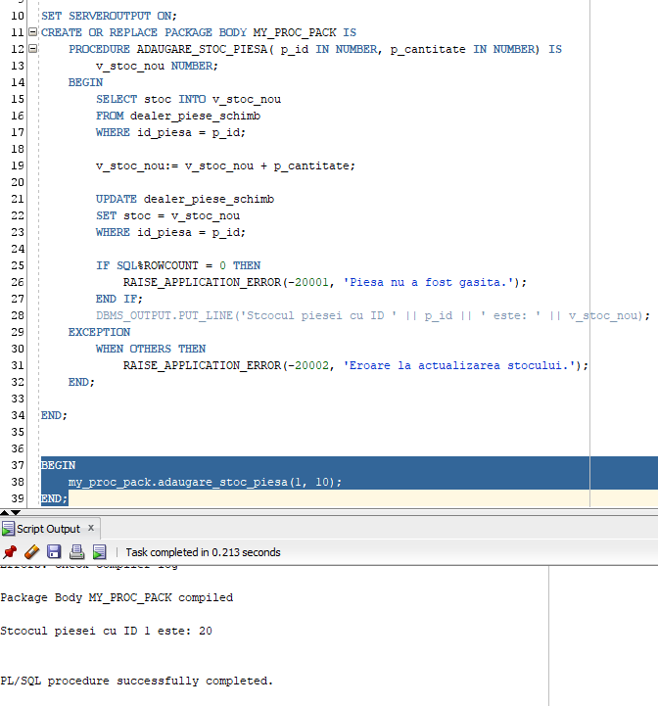

Valoare_inventar_marca:

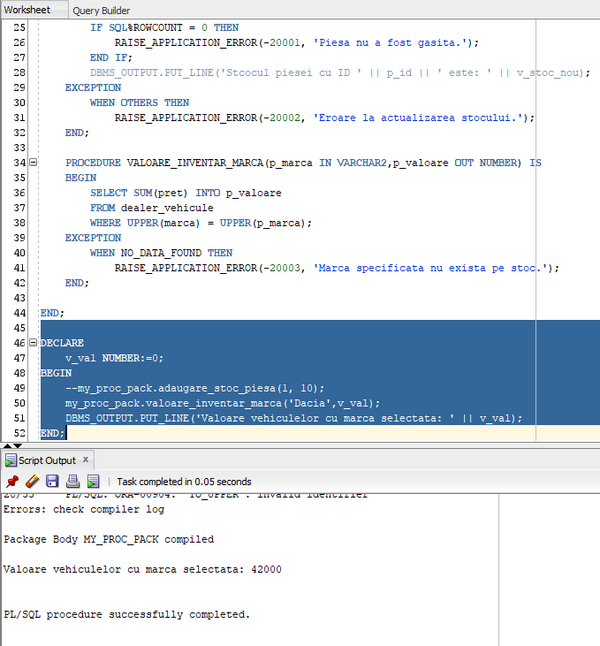

Inserare_client:

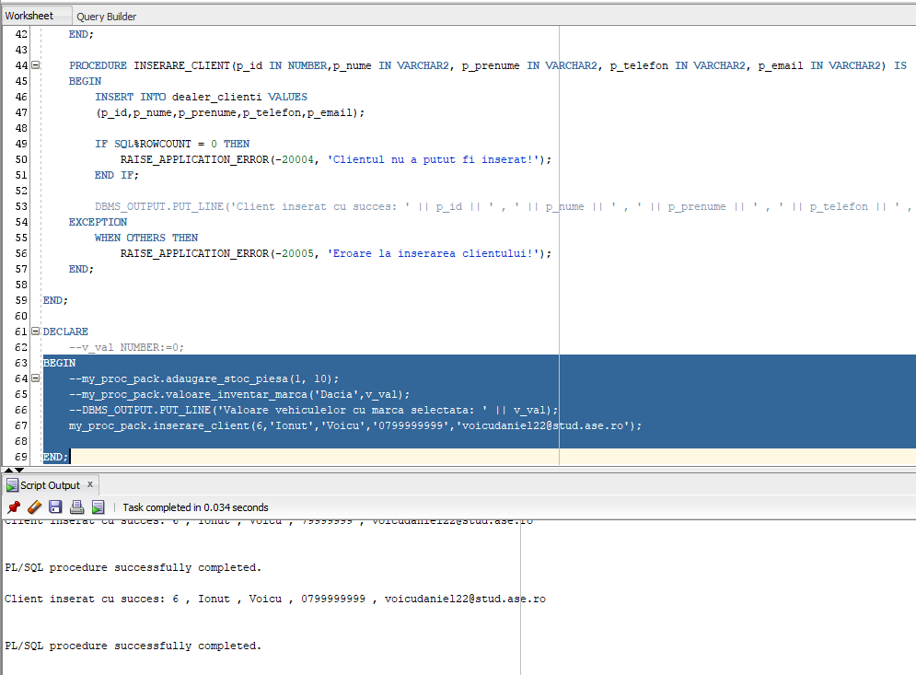

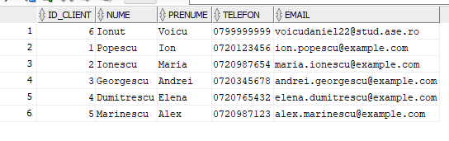

Stergere_vehicul:

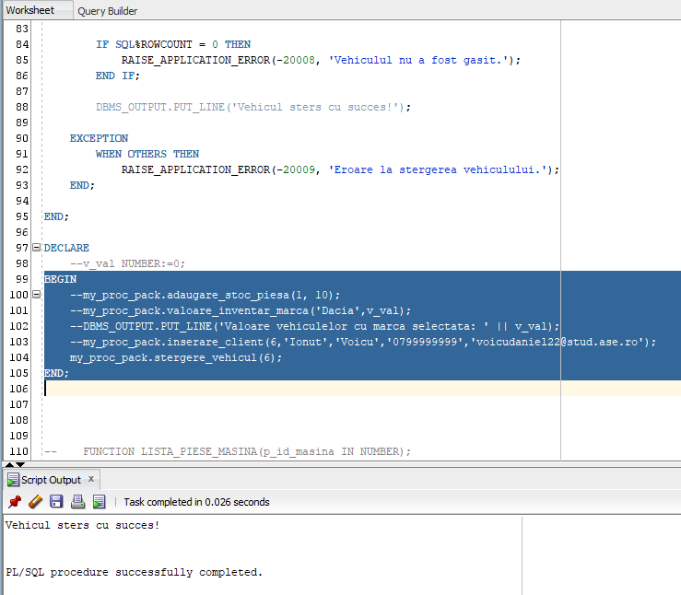

Pachetul MY_FUNC_PACK – 3 functii

Antet:

CREATE OR REPLACE PACKAGE MY_FUNC_PACK IS

FUNCTION LISTA_PIESE_MASINA(p_id_masina IN NUMBER) RETURN VARCHAR2;

FUNCTION VERIFICA_STOC_PIESA(p_id IN NUMBER) RETURN VARCHAR2;

FUNCTION PRET_TOTAL_PIESE_VEHICUL(p_id_masina IN NUMBER) RETURN NUMBER;

END;

Body:

CREATE OR REPLACE PACKAGE BODY MY_FUNC_PACK IS

FUNCTION LISTA_PIESE_MASINA(p_id_masina IN NUMBER) RETURN VARCHAR2 IS

v_lista_piese VARCHAR2(4000);

CURSOR c_piese IS

SELECT nume_piesa

FROM dealer_piese_schimb

WHERE id_vehicul = p_id_masina;

BEGIN

v_lista_piese := '';

FOR r_piesa IN c_piese LOOP

IF v_lista_piese IS NOT NULL THEN

v_lista_piese := v_lista_piese || ', ' || r_piesa.nume_piesa;

ELSE

v_lista_piese := r_piesa.nume_piesa;

END IF;

END LOOP;

IF v_lista_piese IS NULL THEN

v_lista_piese := 'Nu exista piese pentru acest vehicul.';

END IF;

RETURN v_lista_piese;

EXCEPTION

WHEN OTHERS THEN

RETURN 'Eroare la obtinerea listei de piese.';

END;

FUNCTION VERIFICA_STOC_PIESA(p_id IN NUMBER) RETURN VARCHAR2 IS

v_stoc NUMBER;

BEGIN

SELECT stoc

INTO v_stoc

FROM dealer_piese_schimb

WHERE id_piesa = p_id;

IF v_stoc > 0 THEN

RETURN 'Stoc piesa: ' || v_stoc;

ELSE

RETURN 'Piesa nu este disponibila in stoc.';

END IF;

EXCEPTION

WHEN NO_DATA_FOUND THEN

RETURN 'Piesa nu a fost gasita.';

WHEN OTHERS THEN

RAISE_APPLICATION_ERROR(-20010, 'Eroare la verificarea stocului piesei.');

END;

FUNCTION PRET_TOTAL_PIESE_VEHICUL(p_id_masina IN NUMBER) RETURN NUMBER IS

v_total NUMBER := 0;

BEGIN

SELECT SUM(pret)

INTO v_total

FROM dealer_piese_schimb

WHERE id_vehicul = p_id_masina;

RETURN NVL(v_total, 0);

EXCEPTION

WHEN NO_DATA_FOUND THEN

RETURN 0;

WHEN OTHERS THEN

RAISE_APPLICATION_ERROR(-20011, 'Eroare la calcularea pretului total al pieselor.');

END;

END;

Apeluri:

DECLARE

v_lista_piese VARCHAR2(4000);

v_id NUMBER := 1;

v_ret VARCHAR2(500);

v_total NUMBER := 0;

BEGIN

v_lista_piese := my_func_pack.lista_piese_masina(1);

DBMS_OUTPUT.PUT_LINE('Lista pieselor pentru masina cu ID ' || v_id || ': ' || v_lista_piese);

v_ret := my_func_pack.verifica_stoc_piesa(1);

DBMS_OUTPUT.PUT_LINE(v_ret);

v_total := my_func_pack.pret_total_piese_vehicul(1);

DBMS_OUTPUT.PUT_LINE(v_total);

END;

Screenshot-uri:

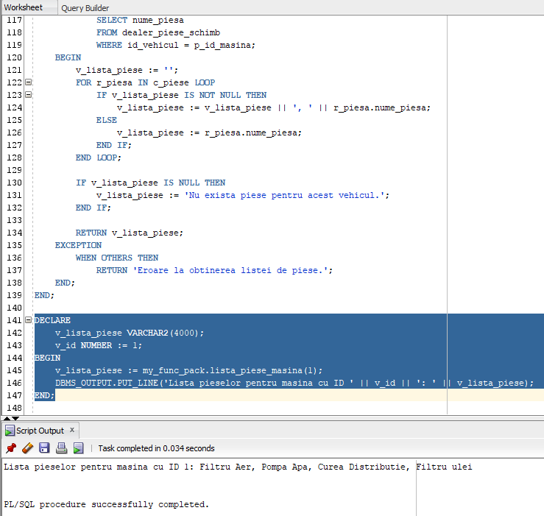Lista_piese_masina:

Verifica_stoc_piesa:

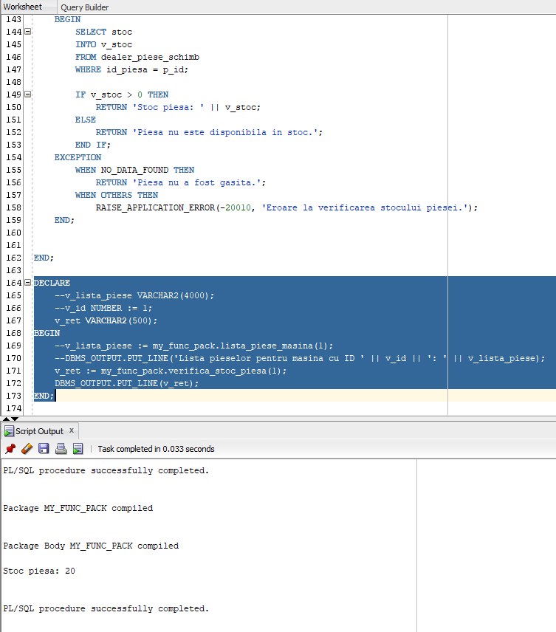

Pret_total_piese_vehicul:

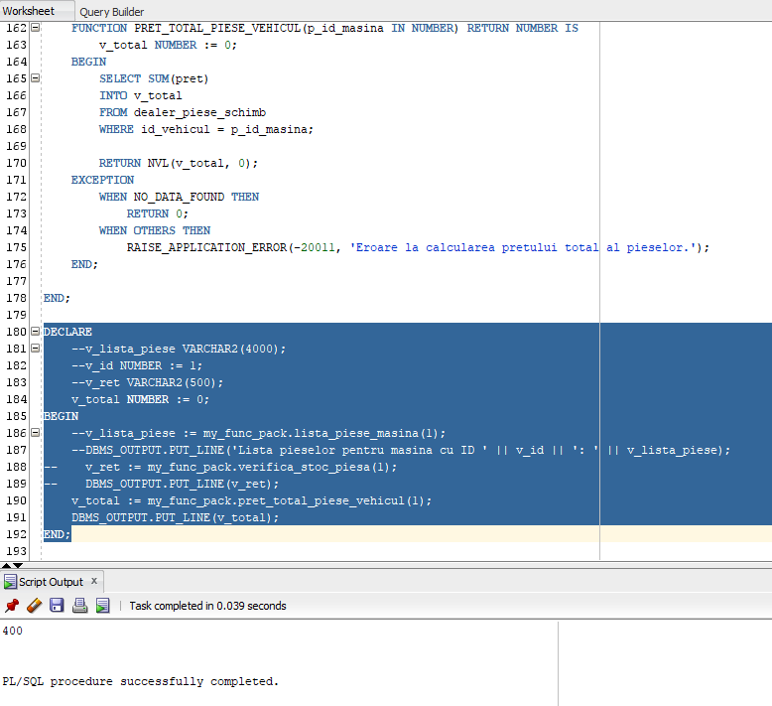

# Triggers:

1. Trigger care actualizeaza automat id-ul unui vehicul inserat in BD:

CREATE OR REPLACE TRIGGER TRG_PK_VEHICUL

BEFORE INSERT ON DEALER_VEHICULE

FOR EACH ROW

DECLARE

max_id NUMBER;

BEGIN

SELECT MAX(id_vehicul) INTO max_id FROM dealer_vehicule;

:NEW.id_vehicul := max_id+1;

END;

INSERT INTO dealer_vehicule VALUES(NULL,'Dacia','Spring',2023,16000);

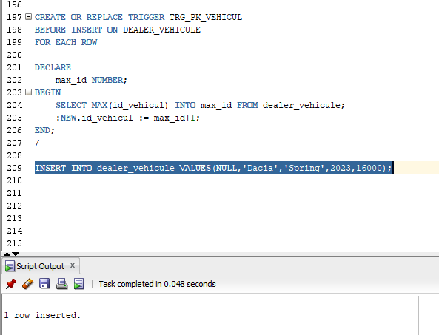

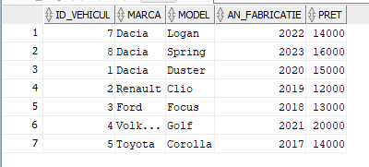

1. Trigger care verifica existenta unui e-mail si nu permite inserarea de dubluri.

CREATE OR REPLACE TRIGGER trg_duplicate_email

BEFORE INSERT OR UPDATE ON dealer_clienti

FOR EACH ROW

DECLARE

v_cnt NUMBER;

BEGIN

SELECT COUNT(*)

INTO v_cnt

FROM dealer_clienti

WHERE email = :NEW.email AND id_client != :NEW.id_client;

IF v_cnt > 0 THEN

RAISE_APPLICATION_ERROR(-20012, 'Adresa de email este deja folosita.');

END IF;

END;

/

INSERT INTO dealer_clienti VALUES(10,'Ion','Ionescu','0733456102','voicudaniel22@stud.ase.ro');

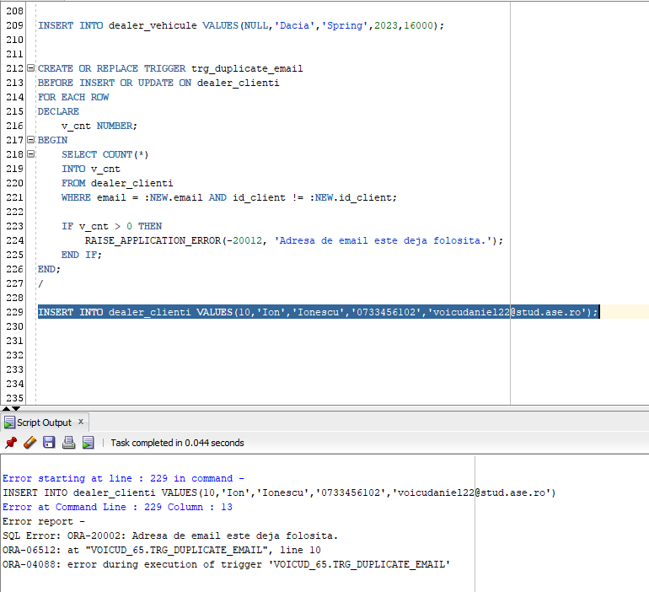

1. Trigger pentru adaugarea unei stergeri intr-o tabela noua (jurnal de stergeri)

* Am folosit acelasi trigger de la punctul 1. Pentru a incrementa automat ID-ul inregistrarii in tabela noua jurnal_stergeri_vehicule.

CREATE TABLE jurnal_stergere_vehicule (

id_jurnal NUMBER PRIMARY KEY,

id_vehicul NUMBER,

marca VARCHAR2(100),

model VARCHAR2(100),

an_fabricatie NUMBER,

pret NUMBER,

data_stergere DATE

);

CREATE OR REPLACE TRIGGER TRG_PK_JURNAL

BEFORE INSERT ON JURNAL_STERGERE_VEHICULE

FOR EACH ROW

DECLARE

max_id NUMBER;

BEGIN

SELECT MAX(id_jurnal) INTO max_id FROM jurnal_stergere_vehicule;

:NEW.id_jurnal := max_id+1;

IF max_id IS NULL THEN

:NEW.id_jurnal := 1;

END IF;

END;

/

* Apoi am creat trigger-ul care creaza intrarea in tabela jurnal o data cu stergerea din tabela vehicule

CREATE OR REPLACE TRIGGER trg_log_stergere_vehicul

AFTER DELETE ON dealer_vehicule

FOR EACH ROW

BEGIN

INSERT INTO jurnal_stergere_vehicule (

id_jurnal, id_vehicul, marca, model, an_fabricatie, pret, data_stergere

) VALUES (

NULL, :OLD.id_vehicul, :OLD.marca, :OLD.model, :OLD.an_fabricatie, :OLD.pret, SYSDATE

);

END;

/

DELETE FROM dealer_vehicule WHERE id_vehicul = 7;

